October STEM
Hurricanes!
Imagine a force that can toss boats around like toys, wash away bridges, and create waves as high as 18 feet. With fierce winds and torrential rains, hurricanes can do all of these things. For centuries people did not know when a hurricane was coming.

Standards

Challenge
Create a house that will survive hurricane winds. The house must have sides walls and a roof. The frame and house walls must not separate from each other during the test.

Constraints
- House must be at least 4 inches tall
- House must stay on its slab or base
- House must survive at least level one wind speed

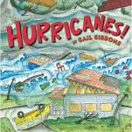
Materials
- Popsicle sticks/tooth picks
- Wall material
- Tape

Tools
- Scissors
- Rulers
- Fan

